# Introduction

Hypertext Markup Language (HTML) is the backbone of the websites and is used to mark up the structure of the web pages. The web pages built using HTML are structured in contents such as paragraphs, bullet points, data tables. HTML utilizes annotated elements using tags enclosed and can be formatted individually to fit what the developer wants (HTML basics, 2021). Some of the tags include <p>, <a>, <h1>, the tags are paired as opening and closing tags. To close the tags are as follows, </p>, </a> and</h1>. Contents of the elements are placed in between the opening and closing tags. The whole of this make-up is what is referred to as an element. All the elements are placed in between the main <html> opening and </html> closing tags.

# Implementing the elements in HTML

1. Paragraphs

First, I have to create skeleton of HTML tags, and these are just standard tags.

<!DOCTYPE html> (this type of this document is HTML)

So then, down here I can start creating what I called container tags.

<htlm> (use html elements to define the structure of this web page)

<head></head>

<title>My first web page</title>

</head>

In our implementation of the code, paragraphs in HTML are set using a <p> tag </p>. The text contents for the paragraph are placed between the tags. Paragraphs elements are used to format many of the texts that are longer than one sentence.

Example of paragraph implementation is:

*<p>*this is a paragraph*</p>*

The snippet of the code:



The output of the code above is as shown below:



1. Bullet points

This is implemented as an unordered list in the HTML web pages. The list of items in the element is bulleted. The primary tag for the bulleted list is <ol>, and the individual items are implemented using the <li> tag.

This has been coded as shown below:

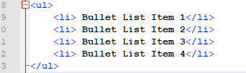

The output is as follows:

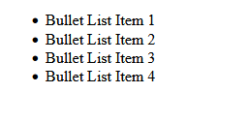

1. Numbered bullet points

The numbered bullet points are coded in HTML in the same way as the bulleted list above except for the <ul> tag, which tells the web page to number the list. The ordered list displays items in the list in numerical order. Additionally, the numbered list can be customized to be alphabetical or roman numerical using ‘’type.’’

The code snippet is as shown below:

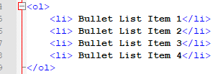

The output is shown below:

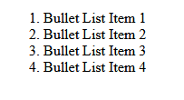

1. Data table

The html web page implementation of a table is by using <table> tag. It shows data in a tabular manner of rows and columns. The <table> tags is used with element tags of <th>, <tr>, <td>. <tr> is used to represent a table row while the <th> tag is a table header and the <td> table data. Table headers <th> is placed between the table rows <tr>.

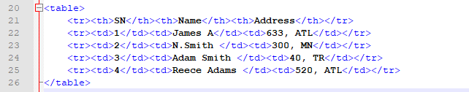

The output of the code above:

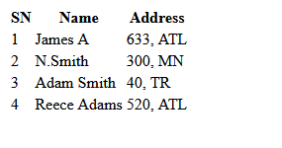

1. Table of contents

There is no HTML element that can out rightly be used to code a table of contents as required. Therefore, for us to implement the requirement, we use a combination of HTML tags and elements to achieve the desired content on a web page. The first element needed is an unordered list to accommodate the items of the table; using this, we can specify our numbering without relying on the auto-generated ones by the HTML. The other important element needed is the link tag *<a>* and *href* to reference the contents pointed in the table of content.

The code is shown as below:

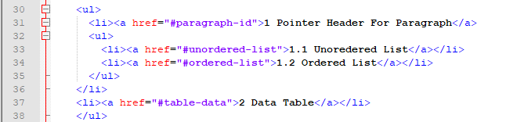

The output generated:

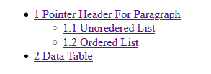

# Challenges and lessons learned

Hypertext markup language has an easy and less challenging learning curve as compared to other web programming tools. Equipped with an integrated development environment or even a basic notepad application, we can achieve most of the tasks. The HTML code that has been written runs on the web browser, and one can view the output of the code and make the necessary changes without many challenges. The basic tags and element implement of structure such as paragraphs, lists are much easy to achieve as compared to the coding of tables and tables of content took most of my time. The total of my work for this report HTML approximately 8 hours, but to figure out the coding of tables and tables of contents took me more than half of that time.

**All the codes herein are in one HTML file, and the overall output is as displayed below:**

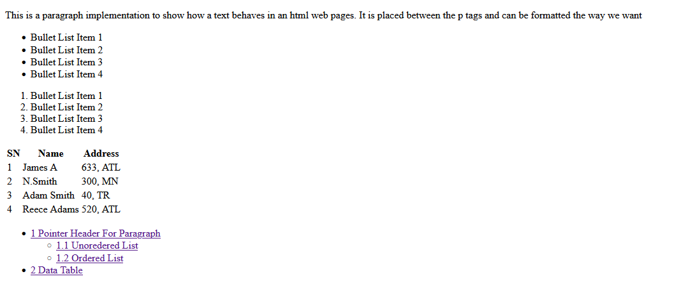

The HTML document is validated using <https://validator.w3.org/>, and the results show no errors.

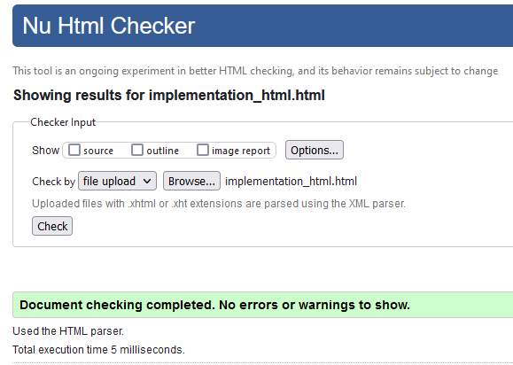

# The Completed assignment should be like this when put it all together

# Implementation of HTML elements

This is a paragraph implementation to show how a text behaves in an html web pages. It is placed between the p tags and can be formatted the way we want (Jackson Nguyen)

* Bullet List Item 1
* Bullet List Item 2
* Bullet List Item 3
* Bullet List Item 4

1. Bullet List Item 1
2. Bullet List Item 2
3. Bullet List Item 3
4. Bullet List Item 4

|  |  |  |
| --- | --- | --- |
| **SN** | **Name** | **School** |
| 1 | James A | 633, ATL |
| 2 | N.Smith | 300, MN |
| 3 | Adam Smith | 40, TR |
| 4 | Reece Adams | 520, ATL |

* 1 Pointer Header For Paragraph
  + 1.1 Unoredered List
  + 1.2 Ordered List
* 2 Data Table

(click 2 times to the icon) its will show on the website what it’s look like

# References

*HTML basics*. (2021, 9 7). Retrieved from developer.mozilla.org: https://developer.mozilla.org/en-US/docs/Learn/Getting_started_with_the_web/HTML_basics